

AMERICAN INTERNATIONAL UNIVERSITY- BANGLADESH(AIUB)

|  |  |
| --- | --- |
| Section :F | Group :12 |

|  |
| --- |
| Project Name : **Blood Donation Management Project** |

|  |  |
| --- | --- |
| Members Name | Members ID |
| MD.JAWADUL HASAN | 20-41958-1 |
| JOY MATUBBER | 20-41959-1 |
| ARITRA DAS | 20-41986-1 |
| ABID HASAN RAPPY | 19-41171-2 |

**CASE STUDY:**

Due to the Chawkbazar Fire Tragedy, the Local Authority is trying to create a database of the current donors of the last month in the area. The Blood collector collects the Blood from the Donors and stores it in the Blood Bank. Blood collectors can collect different groups of blood from many donors. But for the Exceptional case, the blood collectors may fail to collect blood from any donors. The collector is defined by his own name and id. Collectors collect blood from many donors. And, the donor should have their blood group, Donor id, and contact number along with their name, date of birth, and age. There are several blood groups. Every person has a unique Blood group. Each donor can either donate unique blood to the blood bank or may disagree to donate blood if they felt unfit. And the Blood bank has a name, id, blood group, and location where it's situated. The blood bank has all kinds of Blood group collected by the Blood Collectors. Blood collector gives different groups of blood to Blood Bank as per necessity. Blood bank serves the blood to the different hospitals.Hospital also orders a different group of blood from the blood bank according to their need. Hospital has a name, location, id, and number. The hospital can also directly collects a different group of blood from the donor. The patient comes to different hospitals for a checkup. And a patient is defined by his name, number, id, location, blood group.

**ER DIAGRAM :**

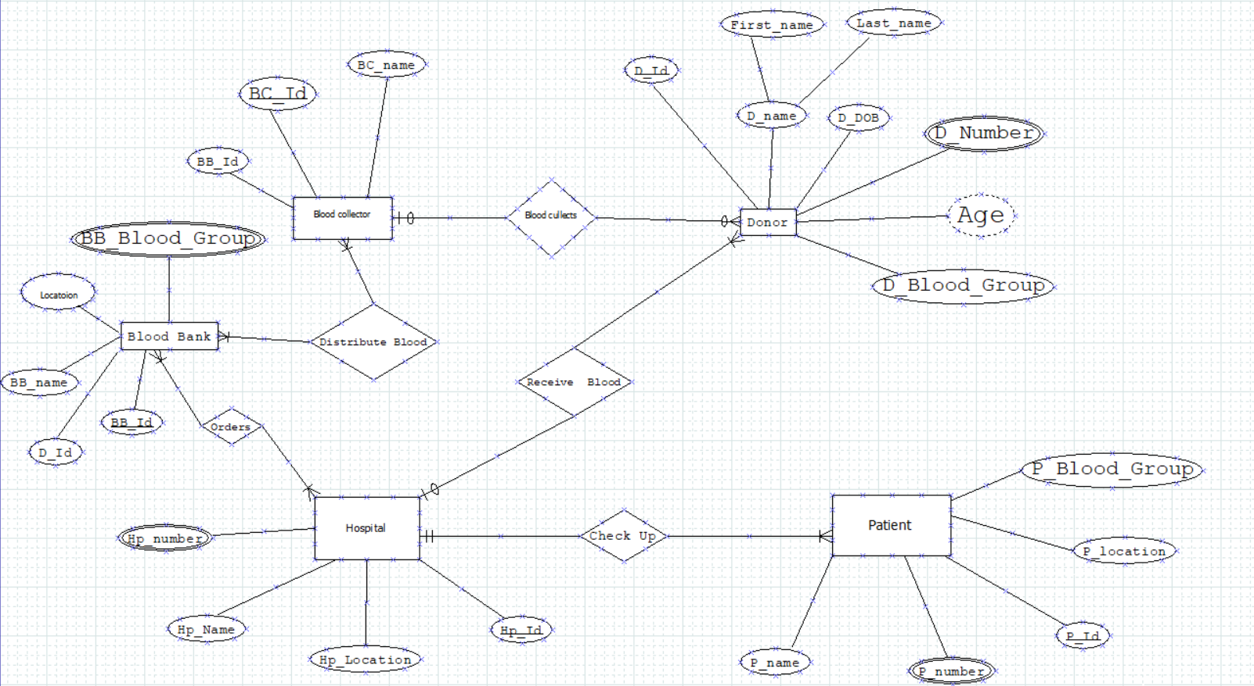

**NORMALIZATION:**

**Blood Collects**(BC_Id ,BB_Id, BC_name,D_Id,First_name,Last_name,D_DOB,D_Number,Age,D_Blood_Group)

**1NF:**

D_Number Multivalued Attribute

**2NF:**

BC_Id, BB_Id, BC_name

D_Id,First_name,Last_name,D_DOB,D_Number,Age,D_Blood_Group , BC_Id

**3NF:**

BC_Id, BB_Id, BC_name

D_Id,First_name,Last_name ,D_Number,D_Blood_Group , BC_Id, DA_Id

DA_Id, D_DOB, Age

**Table :**

BC_Id, BB_Id, BC_name

D_Id, First_name, Last_name , D_Number, D_Blood_Group , BC_Id, DA_Id

DA_Id, D_DOB, Age

**Distribute Blood**(BC_Id, BB_Id, BC_name, BB_Id, D_Id, BB_name, Location, BB_Blood_Group)

**1NF:**

BB_Blood_Group Multivalued Attribute

**2NF:**

BC_Id, BB_Id, BC_name,

BB_Id, D_Id, BB_name, Location, BB_Blood_Group

BN_Id, BC_Id, BB_Id,

**3NF:**

BC_Id, BB_Id, BC_name,

BB_Id, D_Id, BB_name, Location, BB_Blood_Group

BN_Id, BC_Id, BB_Id,

No Transitive Dependency

**Table :**

BC_Id, BB_Id, BC_name,

BB_Id, D_Id, BB_name, Location, BB_Blood_Group

BN_Id, BC_Id, BB_Id,

**Orders** (BB_Id, D_Id, BB_name, Location, BB_Blood_Group, Hp_Id, Hp_Location, Hp_Name, Hp_number )

**1NF :**

BB_Blood_Group, Hp_number are Multivalued Attribute

**2NF:**

BB_Id, D_Id, BB_name, Location, BB_Blood_Group

Hp_Id, Hp_Location, Hp_Name, Hp_number

HB_Id, BB_Id, Hp_Id

**3NF:**

BB_Id, D_Id, BB_name, Location, BB_Blood_Group

Hp_Id, Hp_Location, Hp_Name, Hp_number

HB_Id, BB_Id, Hp_Id

No Transitive Dependency

**Table :**

BB_Id, D_Id, BB_name, Location, BB_Blood_Group

Hp_Id, Hp_Location, Hp_Name, Hp_number

HB_Id, BB_Id, Hp_Id

**Receive Blood**(Hp_Id, Hp_Location, Hp_Name, Hp_number, D_Id,First_name,Last_name,D_DOB,D_Number,Age,D_Blood_Group)

**1NF:**

D_Number, Hp_number Multivalued Attribute

**2NF:**

Hp_Id, Hp_Location, Hp_Name, Hp_number, D_Id,First_name,Last_name,D_DOB,D_Number,Age,D_Blood_Group, Hp_Id,

**3NF:**

Hp_Id, Hp_Location, Hp_Name, Hp_number, D_Id,First_name,Last_name,D_Number, D_Blood_Group, Hp_Id, DA_Id

DA_Id, D_DOB, Age

**Table:**

Hp_Id, Hp_Location, Hp_Name, Hp_number, D_Id,First_name,Last_name,D_Number, D_Blood_Group, Hp_Id, DA_Id

DA_Id, D_DOB, Age

**Check Up**(Hp_Id , Hp_Location, Hp_Name, Hp_number, P_Id ,P_name,P_number,P_locaction,P_Blood_Group)

**1NF:**

Hp_number, P_number are Multivalued Atribute

**2NF:**

Hp_Id , Hp_Location, Hp_Name, Hp_number,

P_Id ,P_name,P_number ,P_locaction,P_Blood_Group

PH_Id, Hp_Id , P_Id

**3NF:**

Hp_Id , Hp_Location, Hp_Name, Hp_number,

P_Id ,P_name,P_number ,P_locaction,P_Blood_Group

PH_Id, Hp_Id , P_Id

No Transitive Dependency

**Table :**

Hp_Id , Hp_Location, Hp_Name, Hp_number,

P_Id ,P_name,P_number ,P_locaction,P_Blood_Group

PH_Id, Hp_Id , P_Id

**Total Table**

BC_Id, BB_Id, BC_name

D_Id, First_name, Last_name , D_Number, D_Blood_Group , BC_Id, DA_Id

DA_Id, D_DOB, Age

**~~BC_Id, BB_Id, BC_name,~~**

BB_Id, D_Id, BB_name, Location, BB_Blood_Group

BN_Id, BC_Id, BB_Id,

**~~BB_Id, D_Id, BB_name, Location, BB_Blood_Group~~**

Hp_Id, Hp_Location, Hp_Name, Hp_number

HB_Id, BB_Id, Hp_Id

**~~Hp_Id, Hp_Location, Hp_Name, Hp_number,~~** D_Id,First_name,Last_name,D_Number, D_Blood_Group, Hp_Id, DA_Id

**~~DA_Id, D_DOB, Age~~**

**~~Hp_Id , Hp_Location, Hp_Name, Hp_number,~~**

P_Id ,P_name,P_number ,P_locaction,P_Blood_Group

PH_Id, Hp_Id , P_Id

**Final Table :**

BC_Id, BB_Id, BC_name

D_Id, First_name, Last_name , D_Number, D_Blood_Group , BC_Id, DA_Id

DA_Id, D_DOB, Age

BB_Id, D_Id, BB_name, Location, BB_Blood_Group

BN_Id, BC_Id, BB_Id

Hp_Id, Hp_Location, Hp_Name, Hp_number

HB_Id, BB_Id, Hp_Id

D_Id,First_name,Last_name,D_Number, D_Blood_Group, Hp_Id, DA_Id

P_Id ,P_name,P_number ,P_locaction,P_Blood_Group

PH_Id, Hp_Id , P_Id

**Table Creation With Constarints**

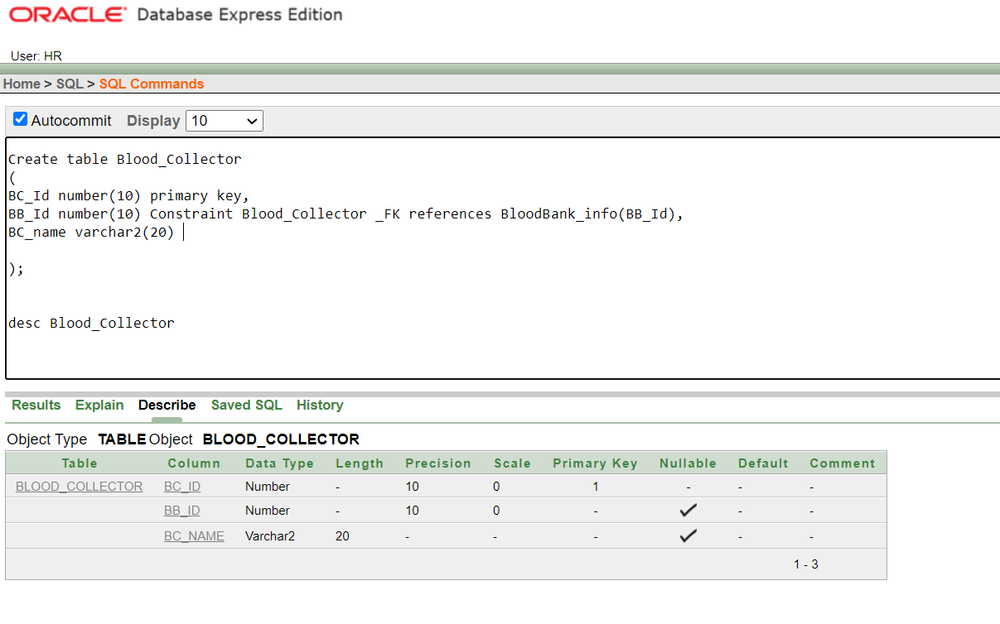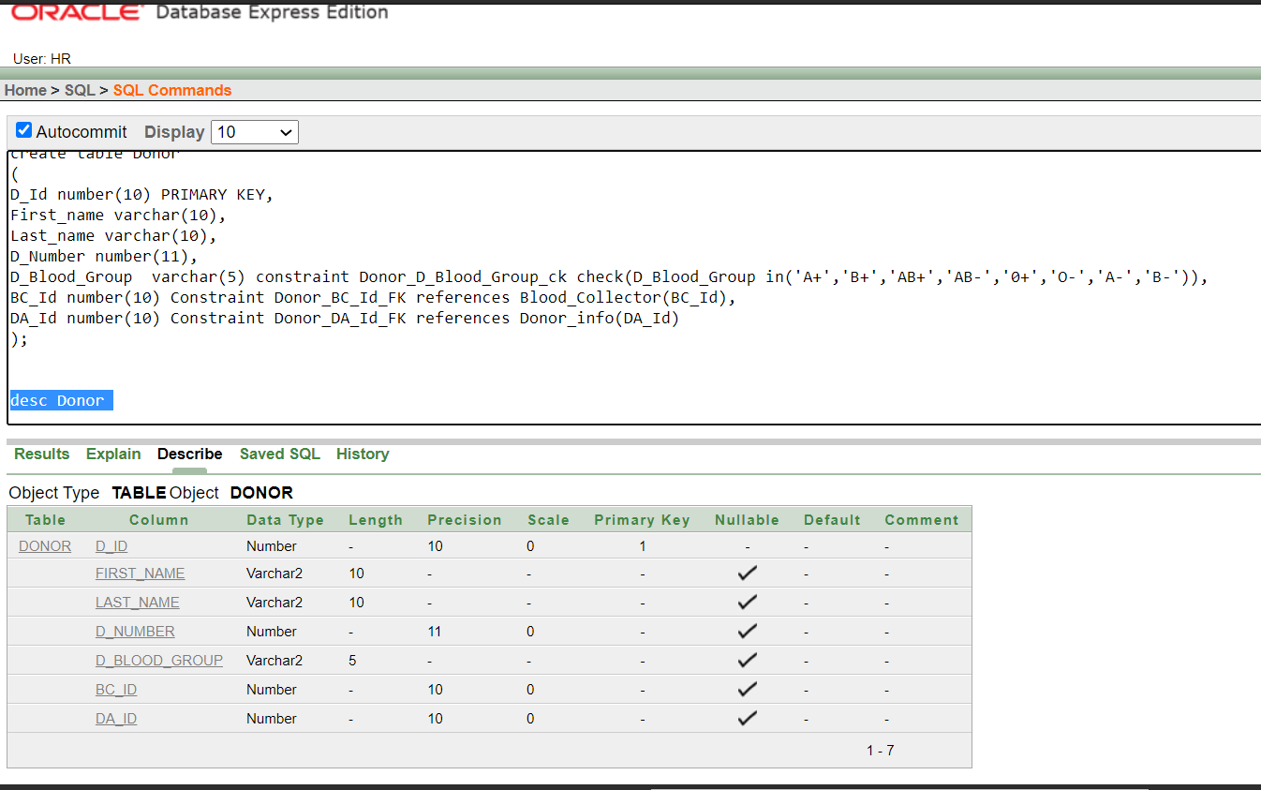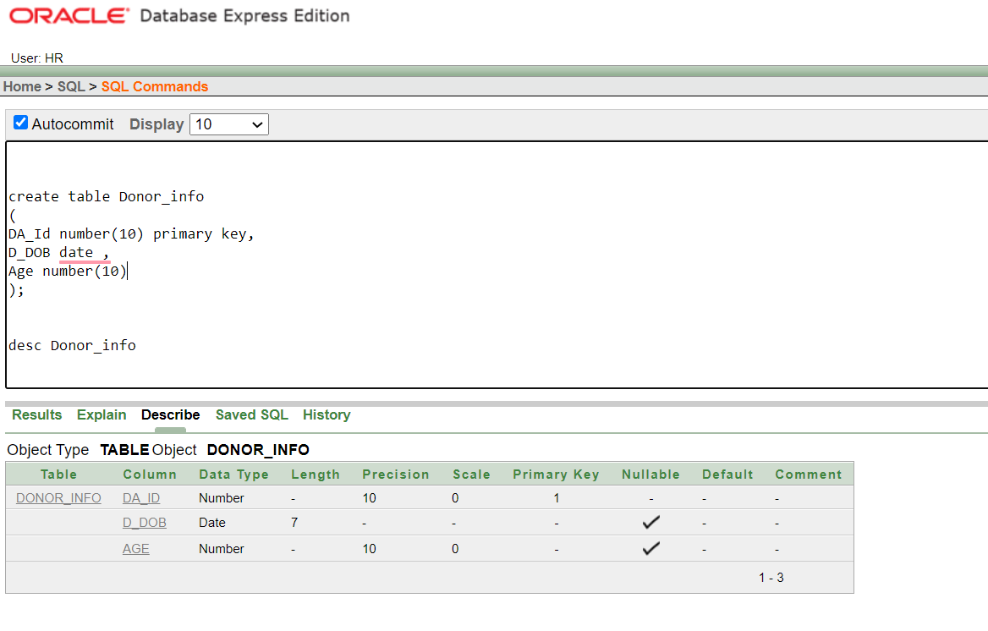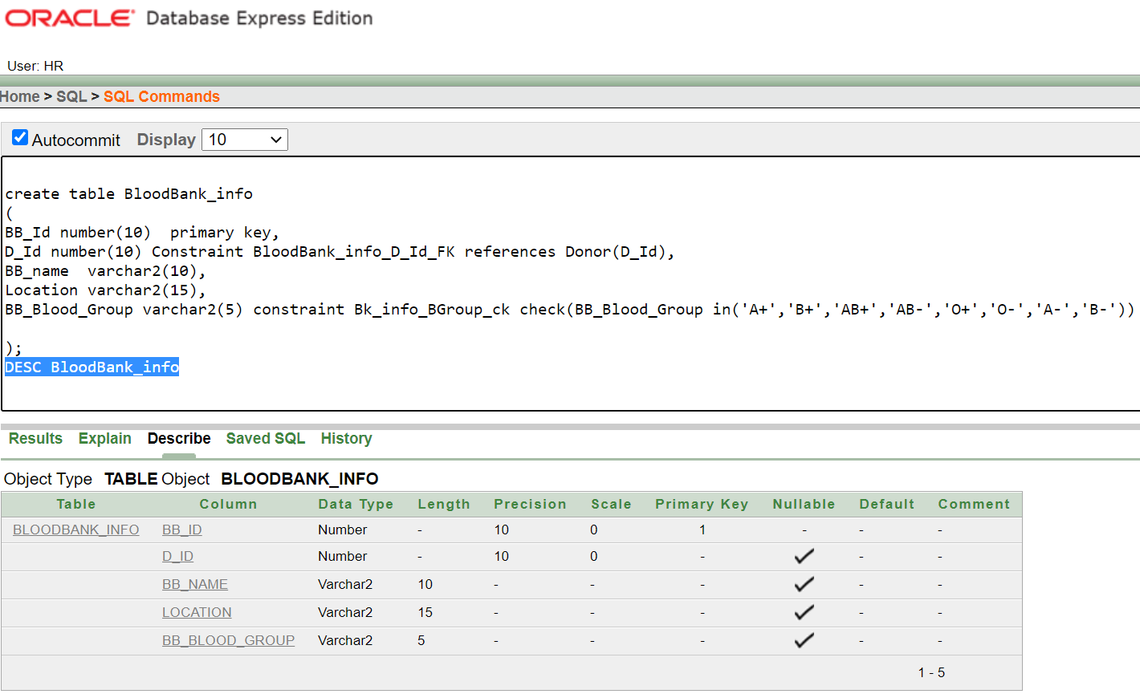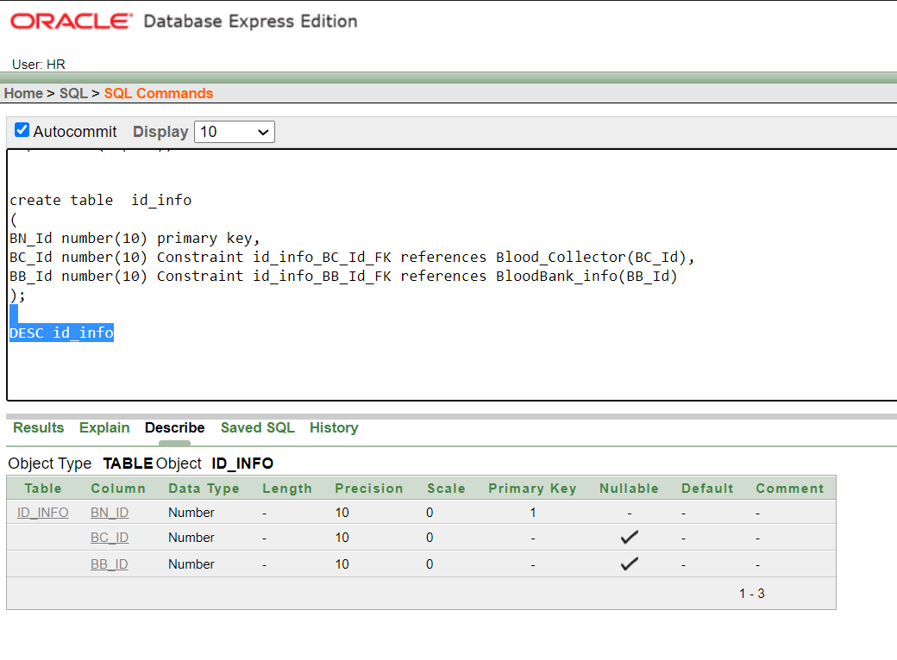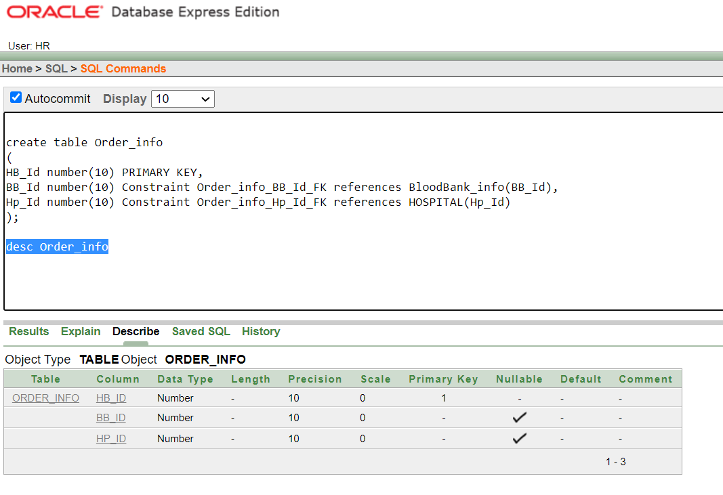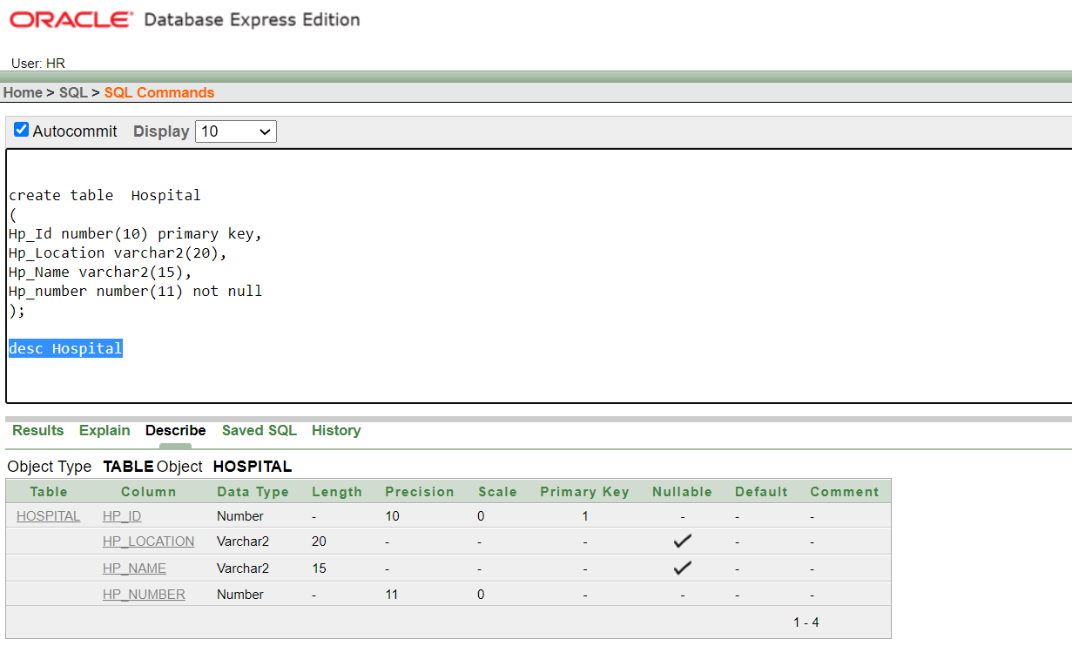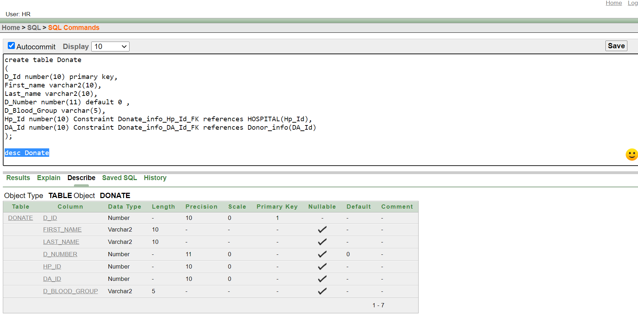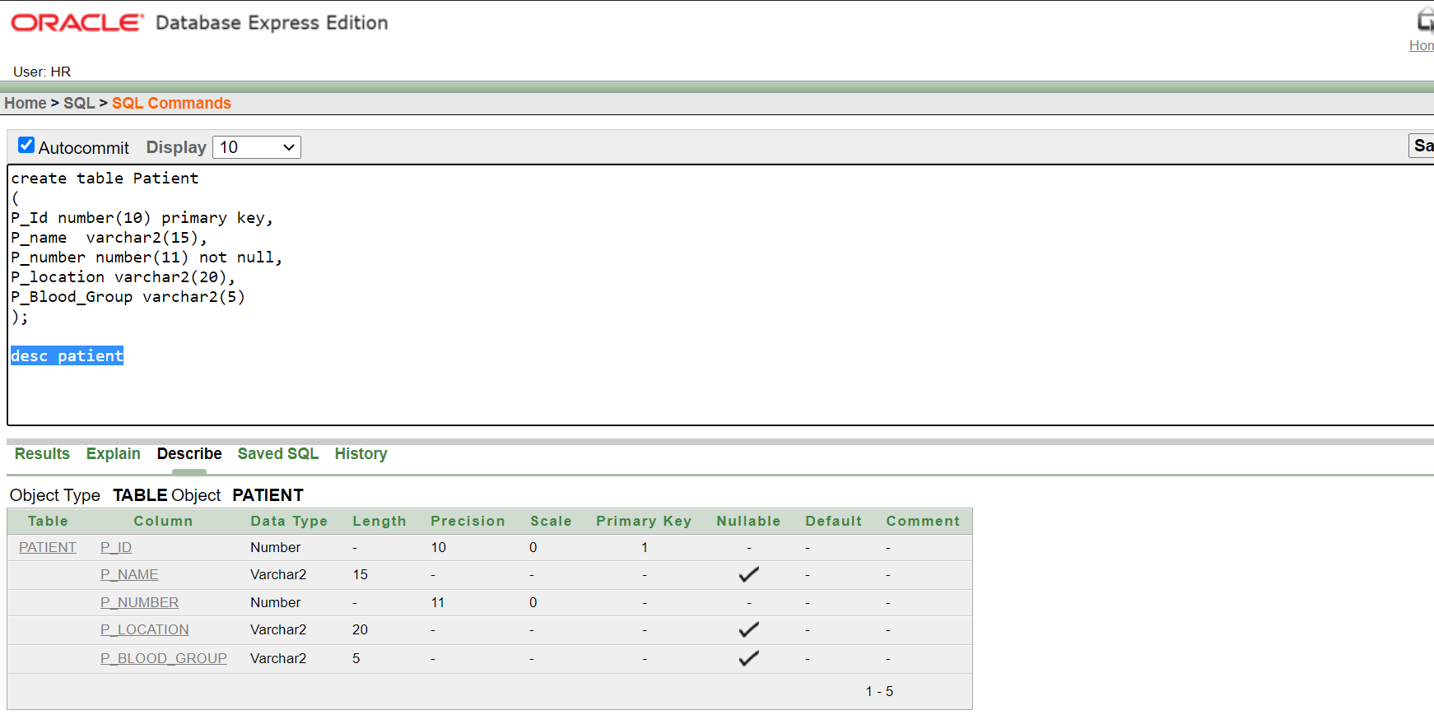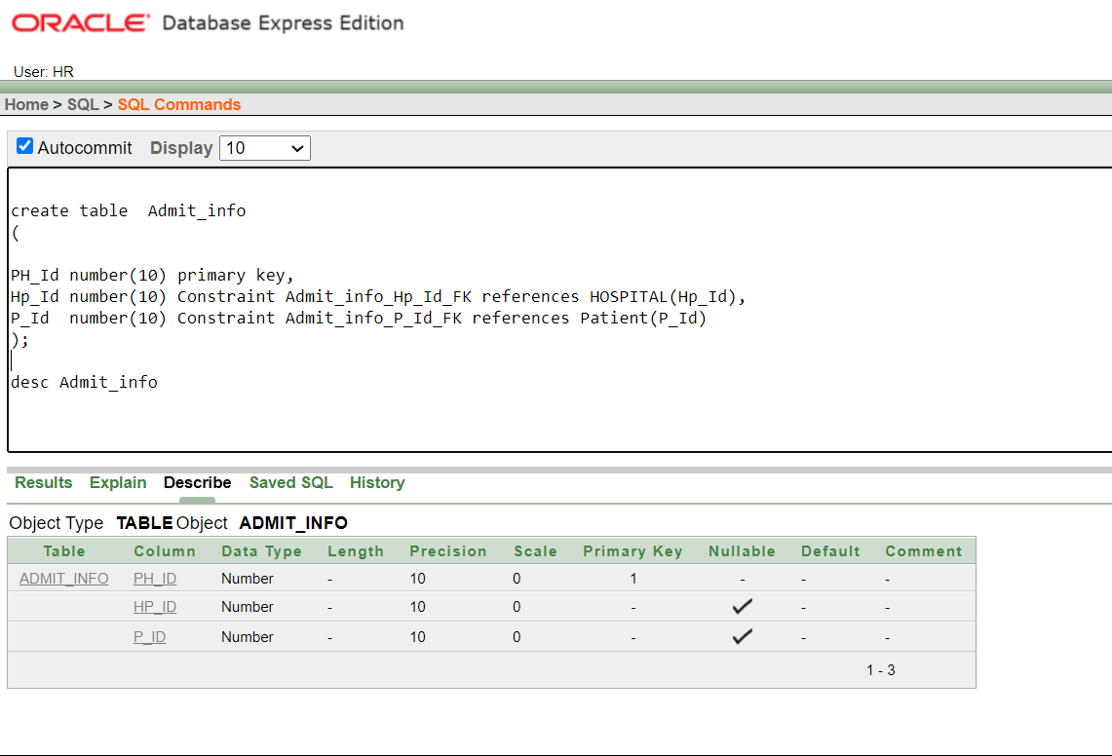

**Data Insertion**

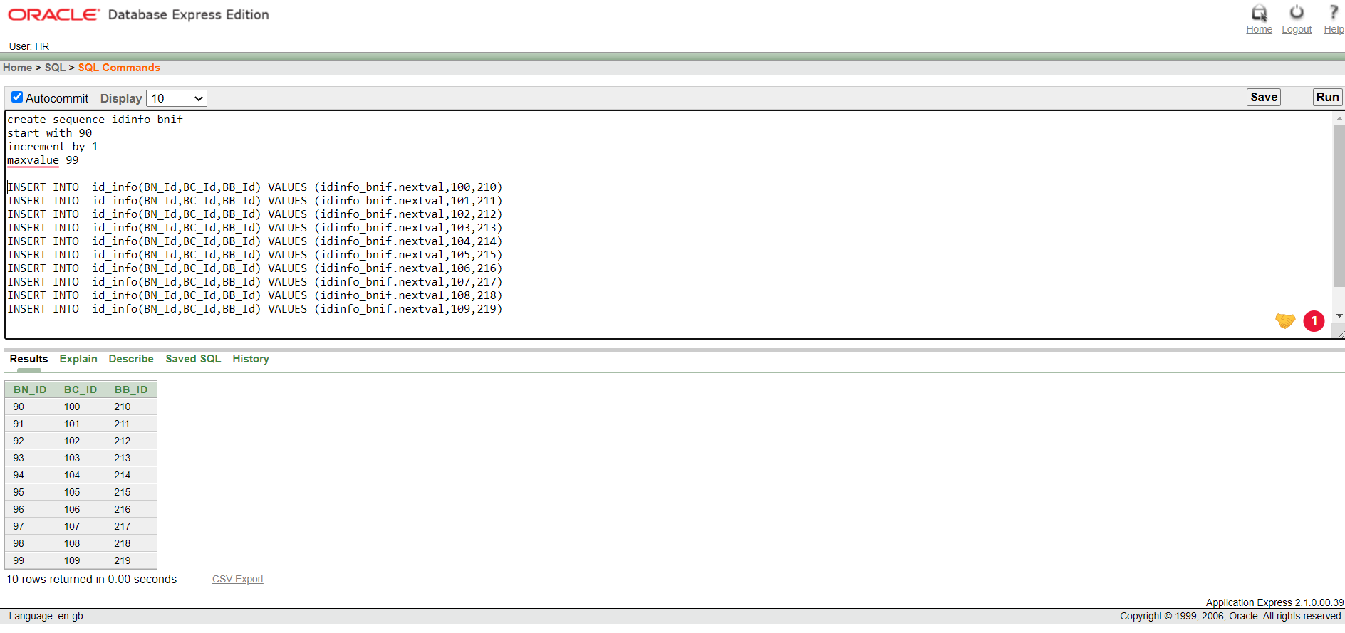

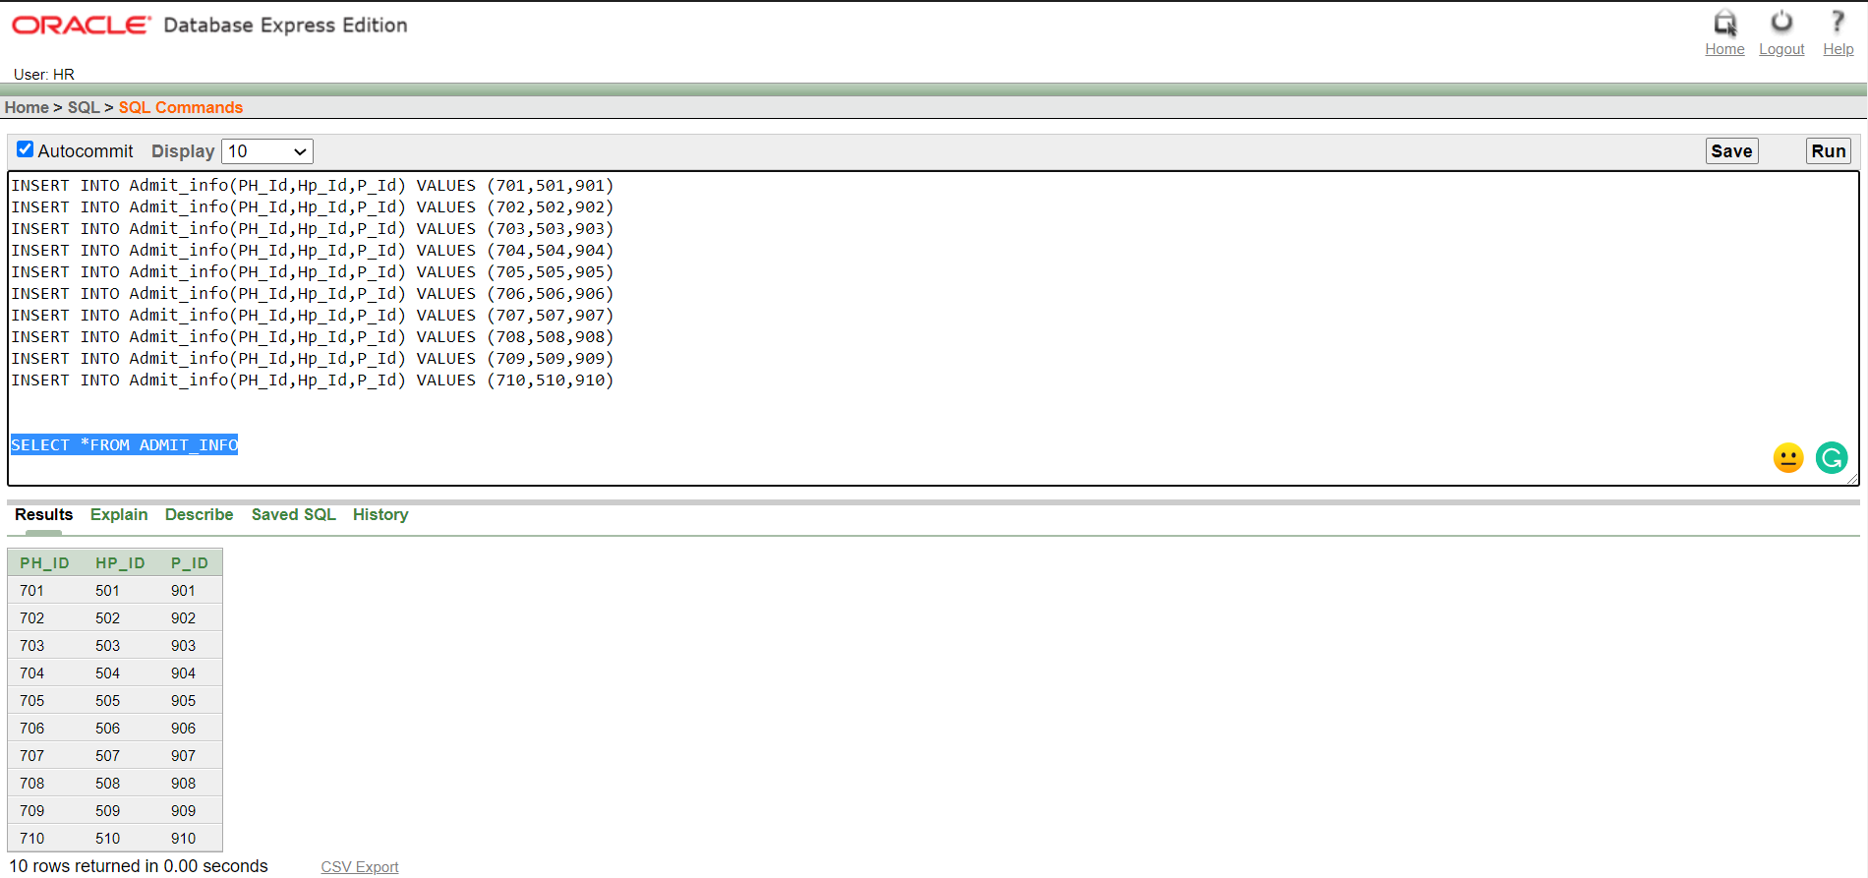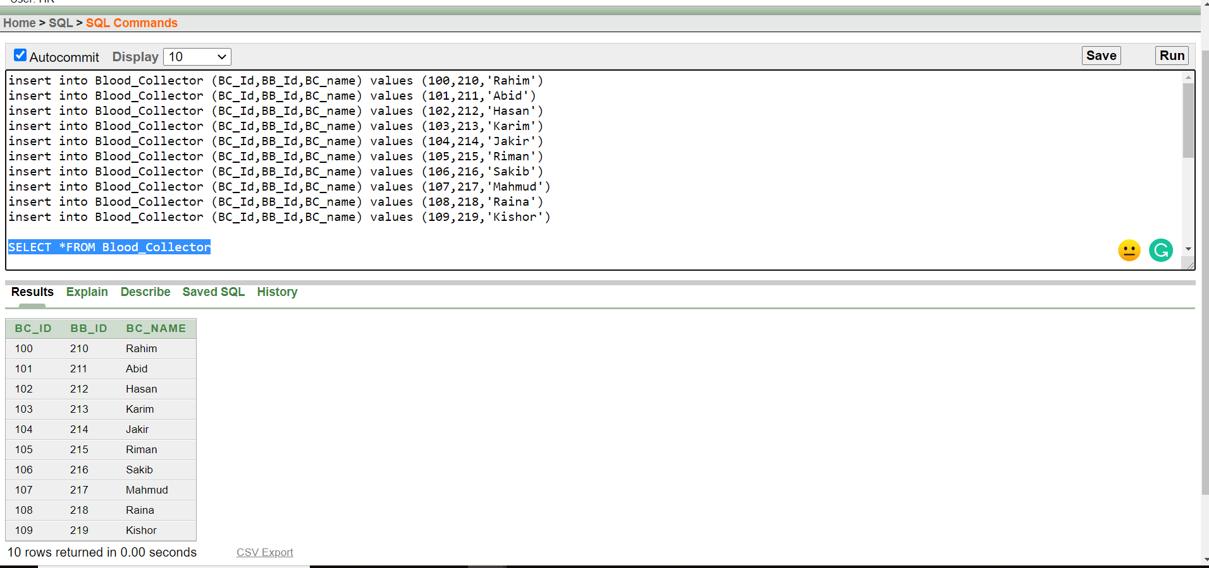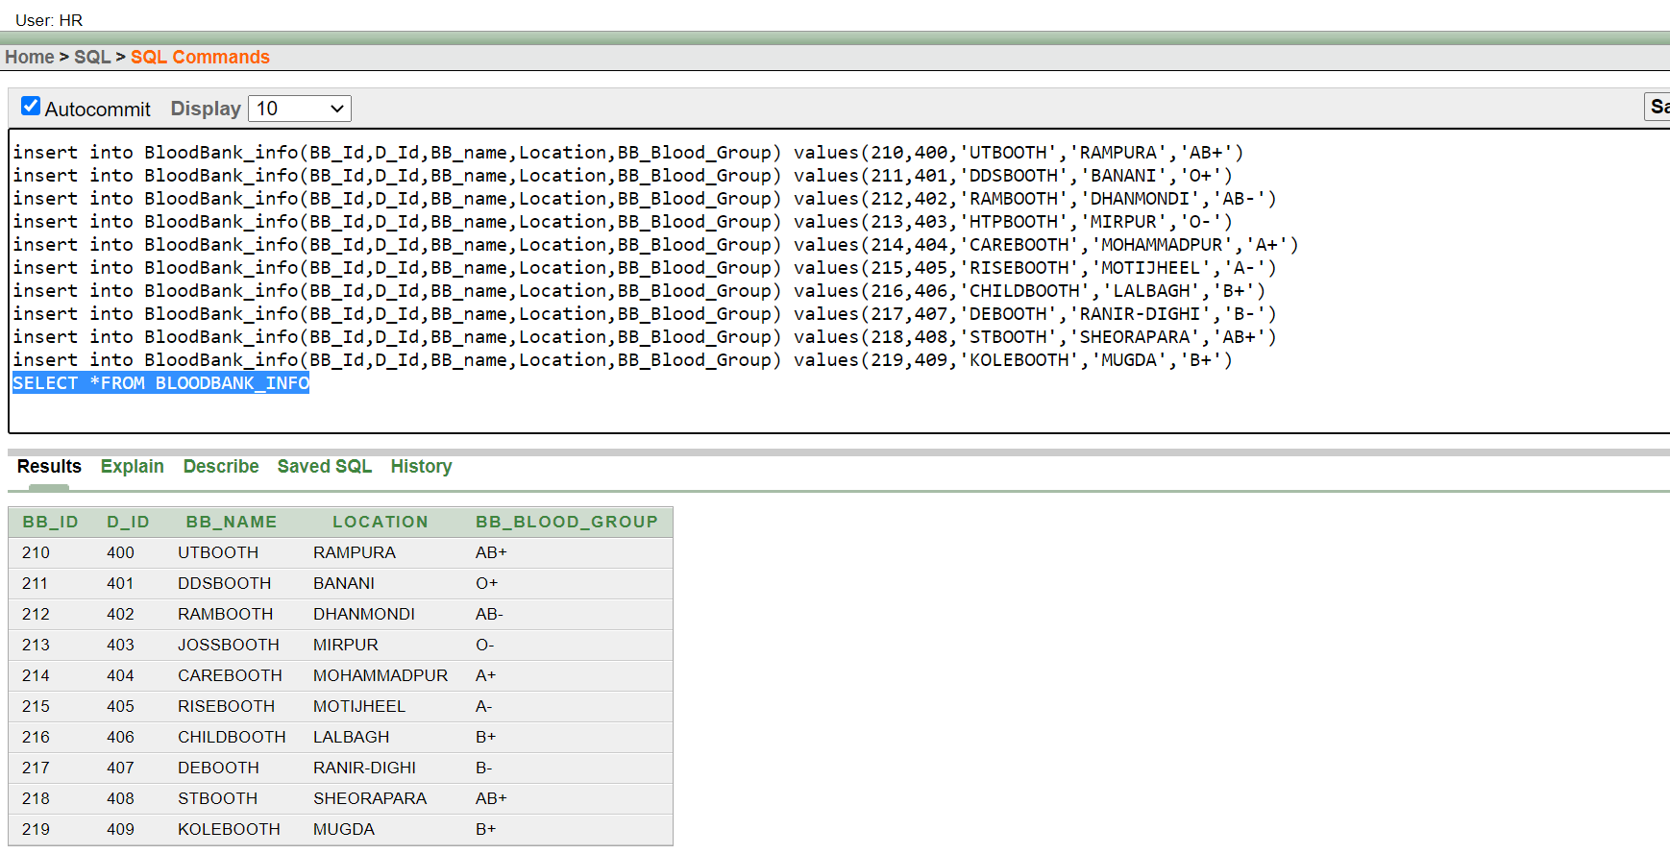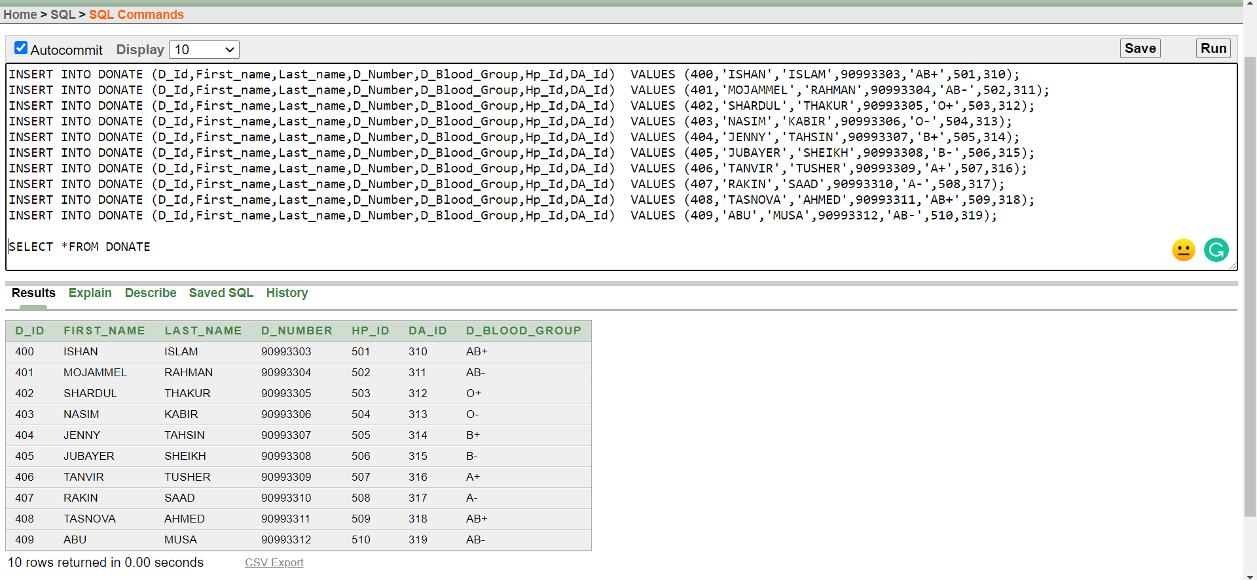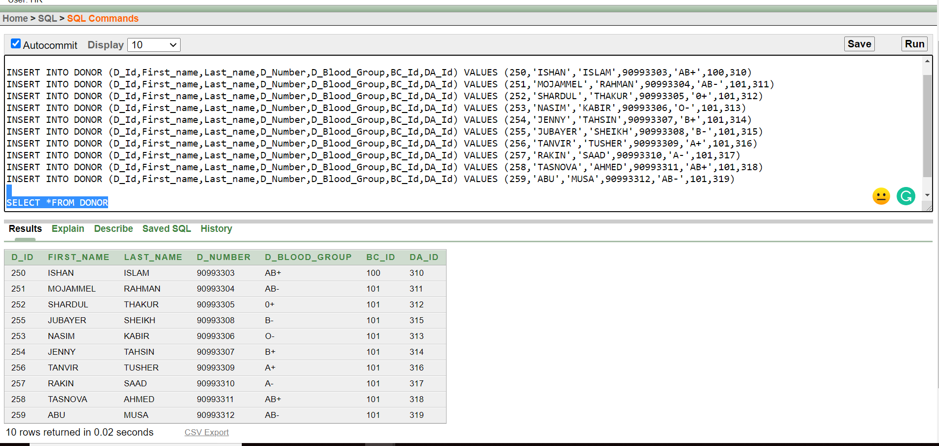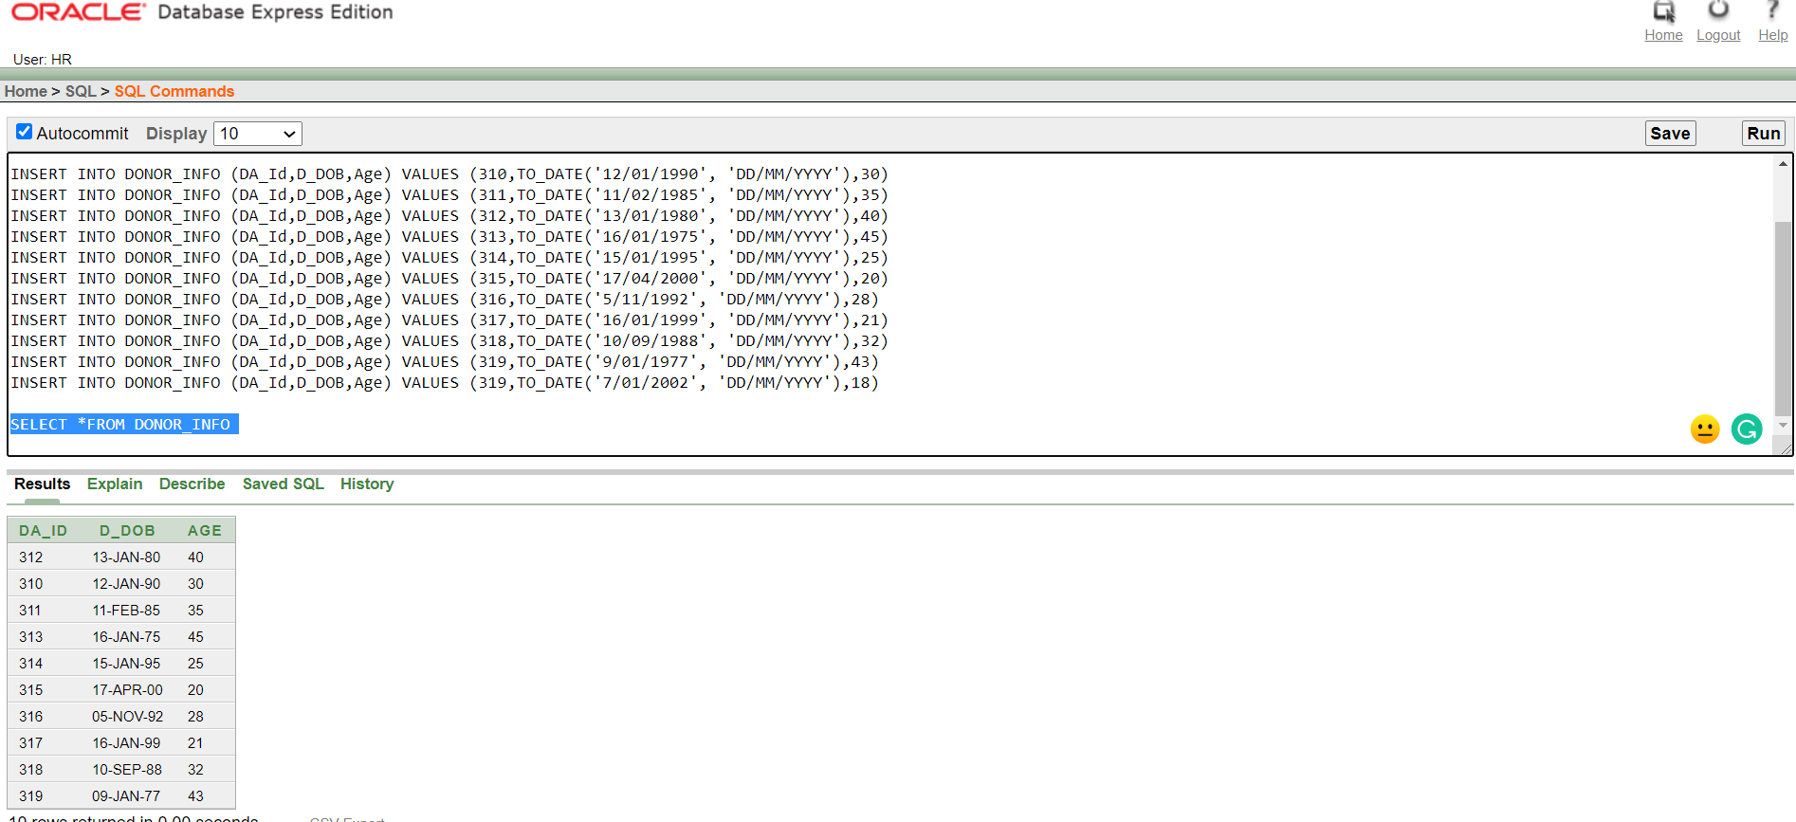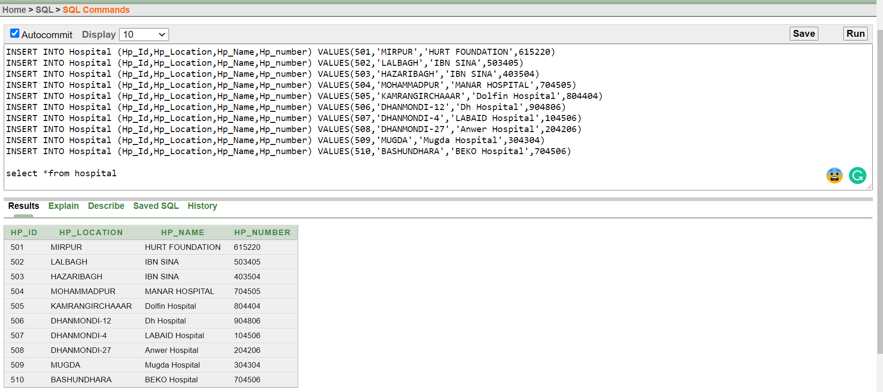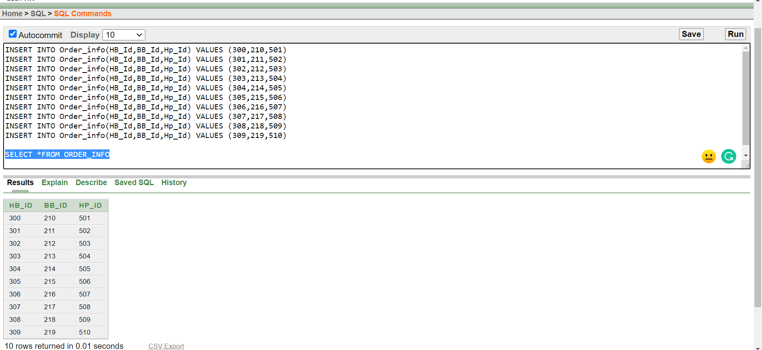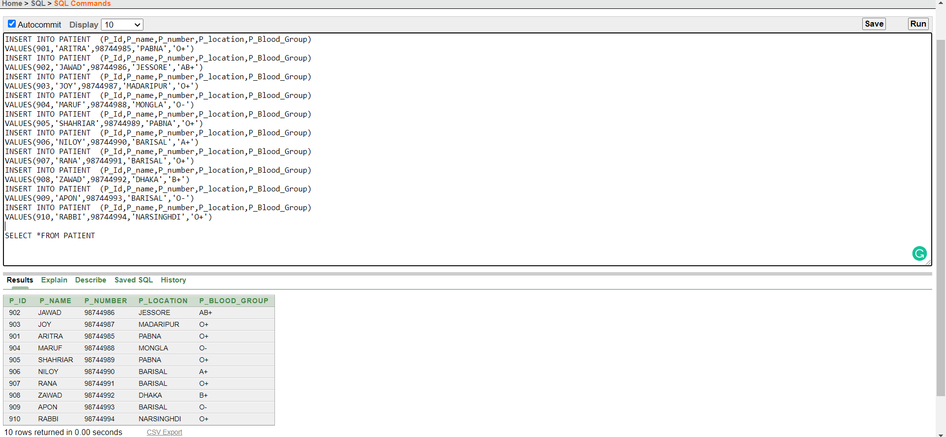

**Query writing on the tables**

**Question 1 (View) :** Create a view that conatins Blood Bank name,Donor name where blood group matches for both case.

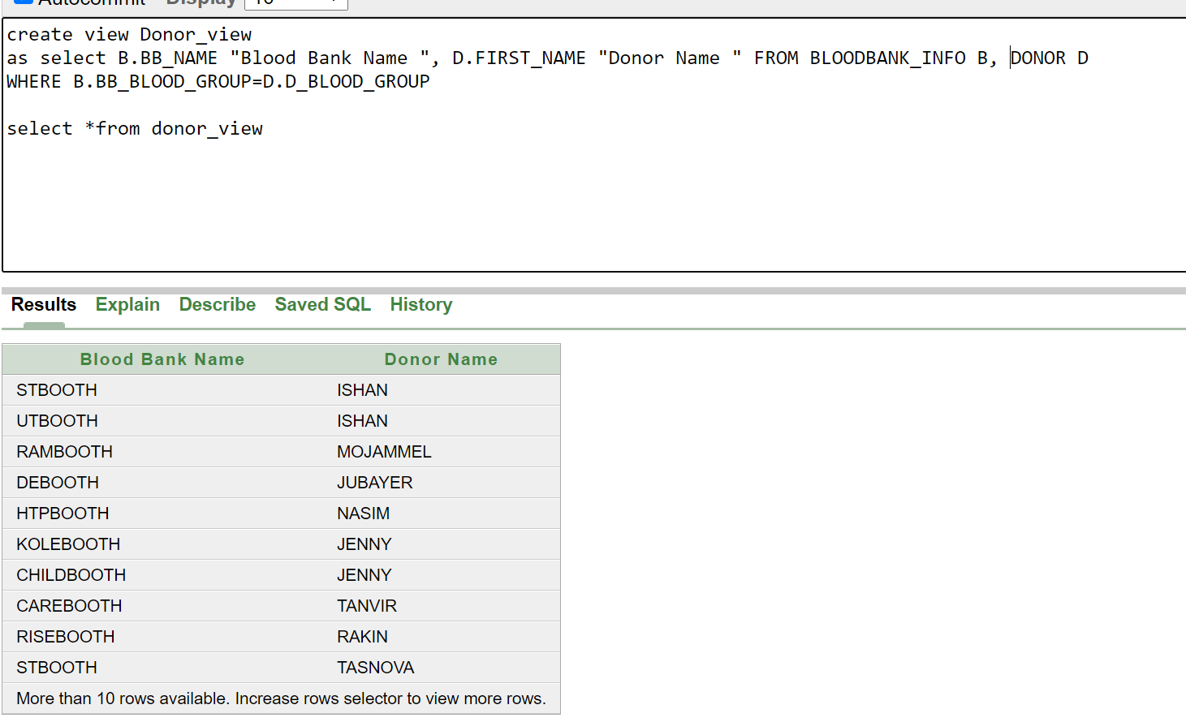

**Question 2 (Subquery ):** Display the id,name,location,blood group from the patient whose location is same as the b+ blood holder blood bank or those whose blood group is same as the donorwhose id is 257 or 258

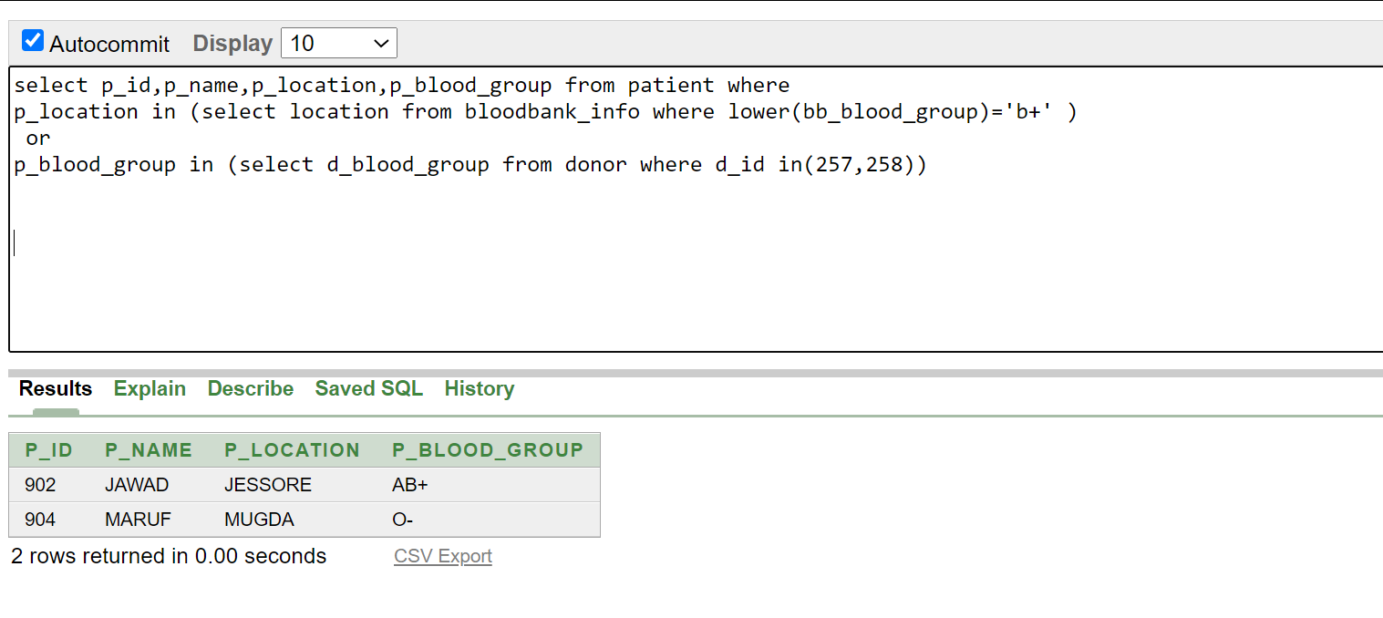

**Question 3 (Subquery ):** Display the id,name,blood group of the Patients whose blood group matches from the donor having id from 250 to 255

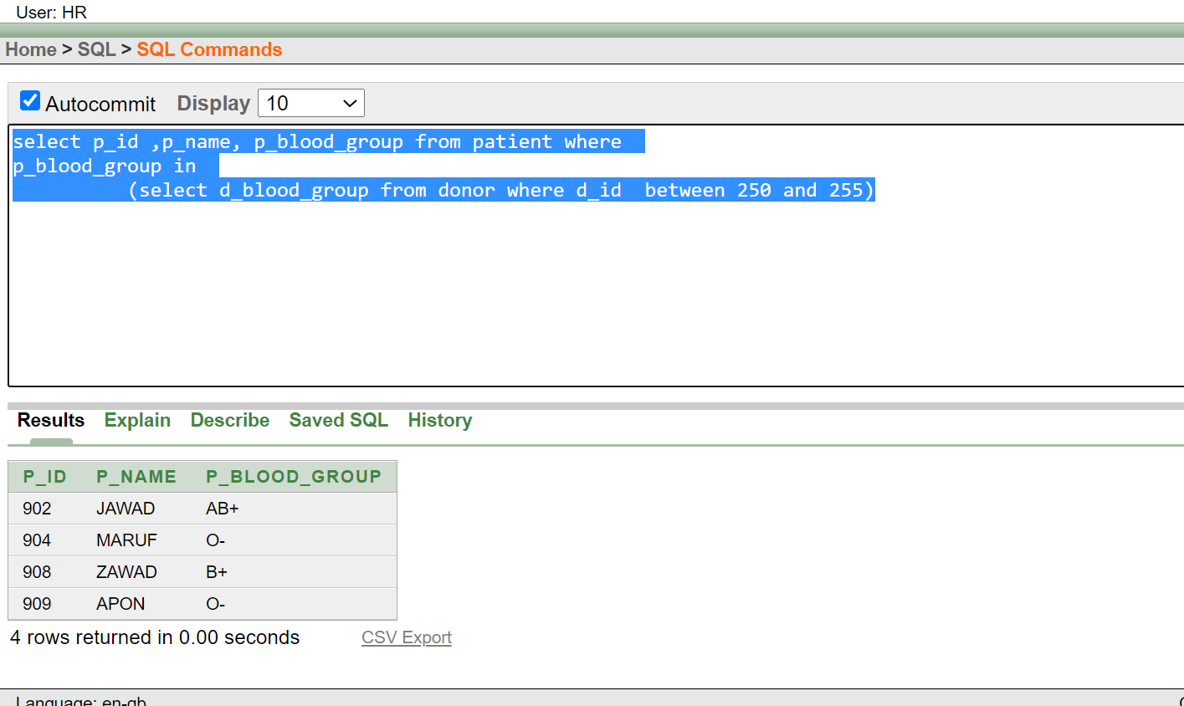

**Question 4 (Subquery ) :** Display the id, name, location of the blood bank which area is the same as the Hospital Named HURT FOUNDATION

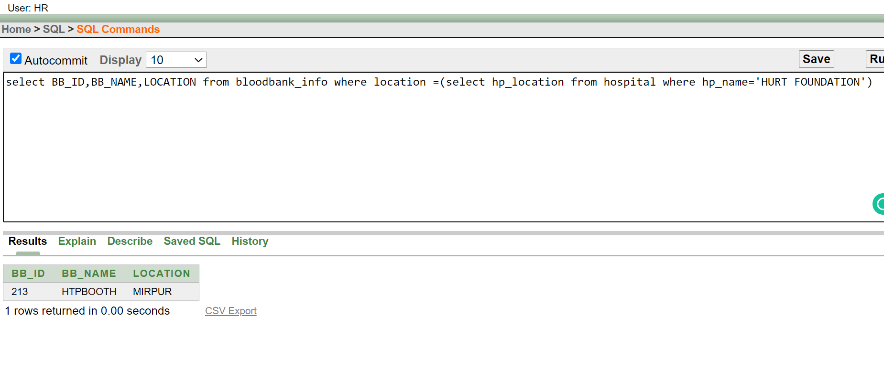

**Question 5 (Joining ) :** Display the name of the donor and patient whose Blood group matched.

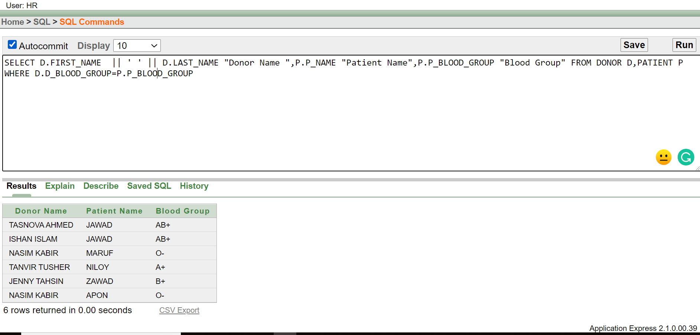

**Question 6 (Joining ) :** Display the Blood Bank name,Donor name and patient name where blood group matches for everywhere and blood bank and patient are in the same area.

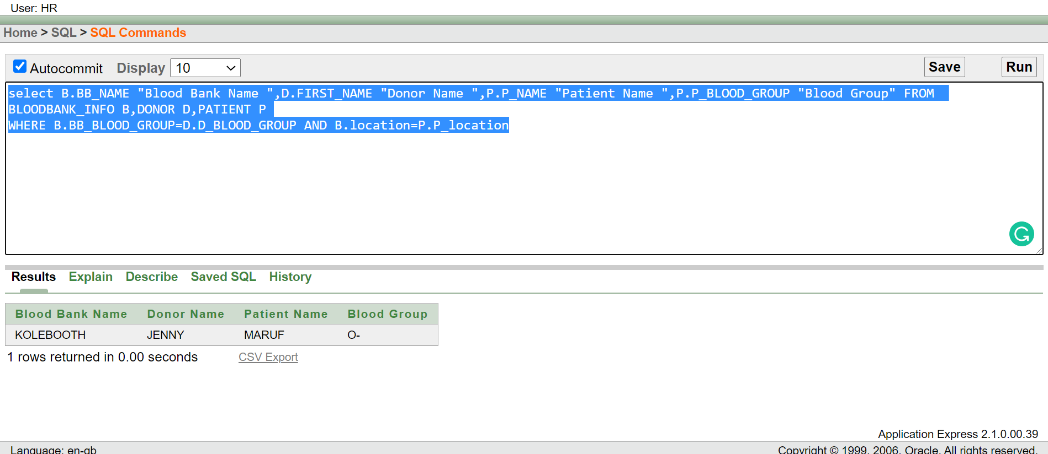

**Question 7 (Joining ) :** Diplay the id,Name,location Blood group of the patient whose areas are the same or not same as a blood bank.

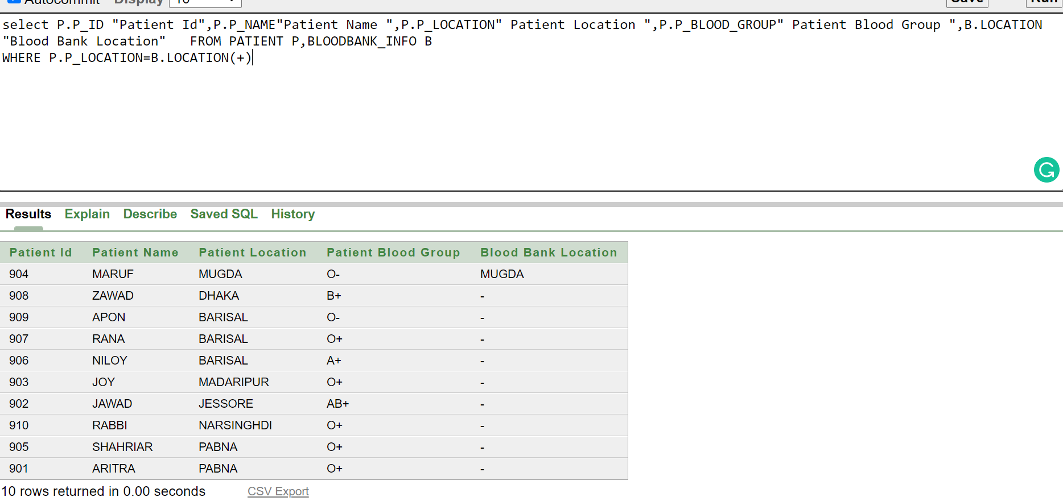

**Question 8 (Group Function ) :** Display the number of people whose age is more than or equal 30 and show the maximum date of birth among them.

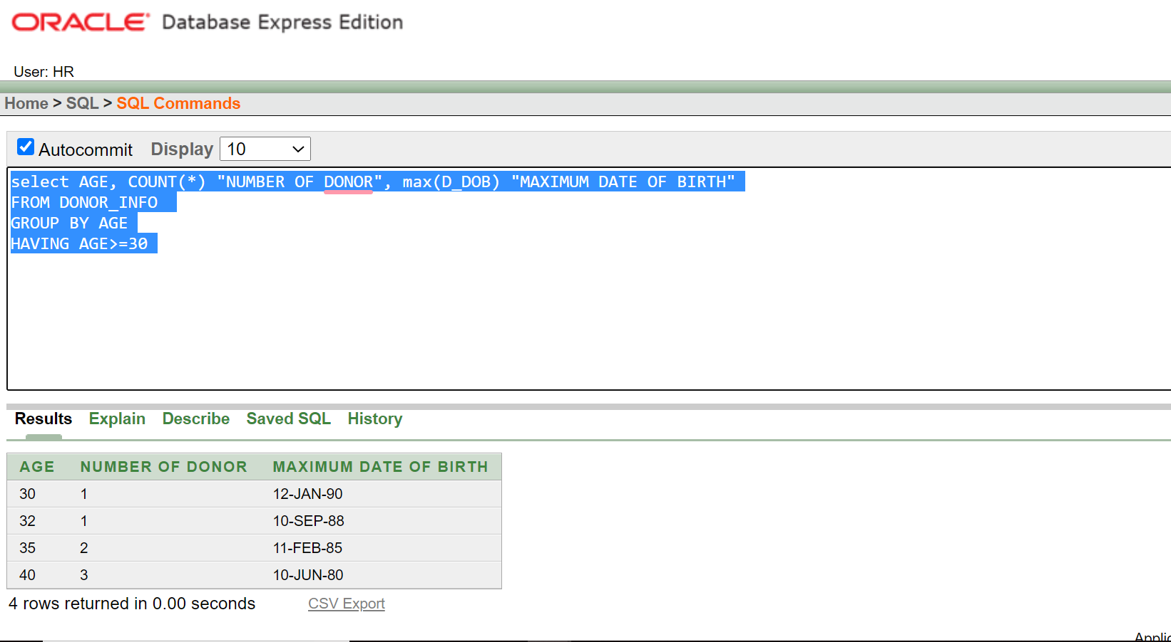

**Question 9 (Group Function ) :** Display the number of Donor having AB+ Blood group

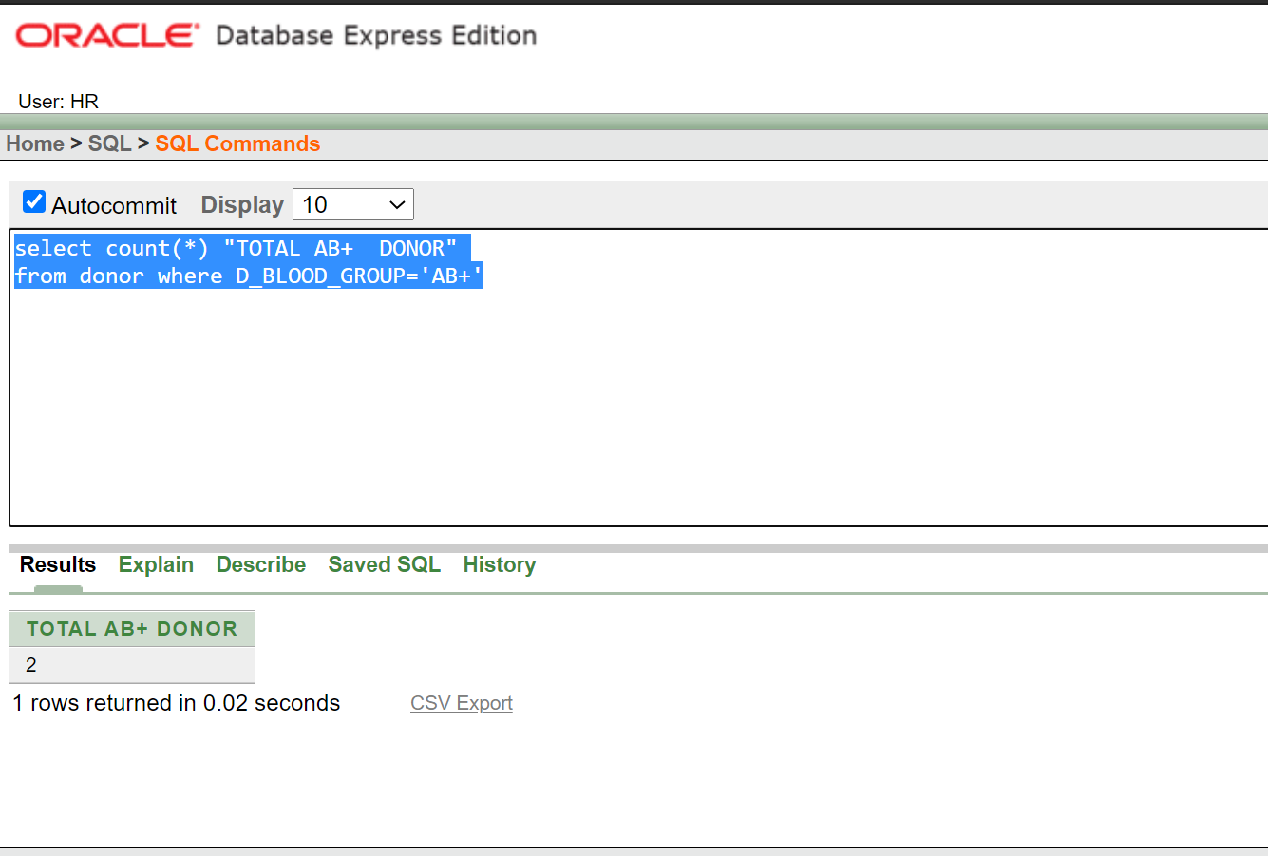

**Question 10 (Group Function ) :** Display the average date of the donor whose age is more than 25.

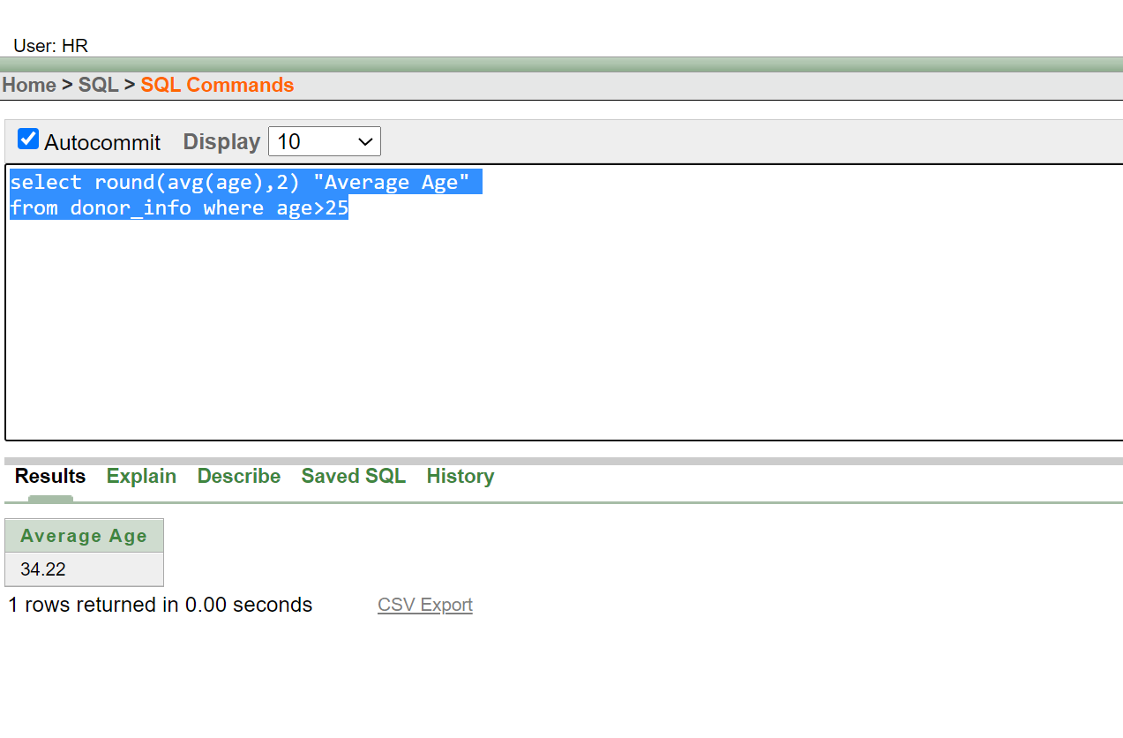

**Question 11 (Single row funciton ) :** Display the name including first name, last name with a capital letter in the initial word and blood group those who have the blood group ab+ or ab-

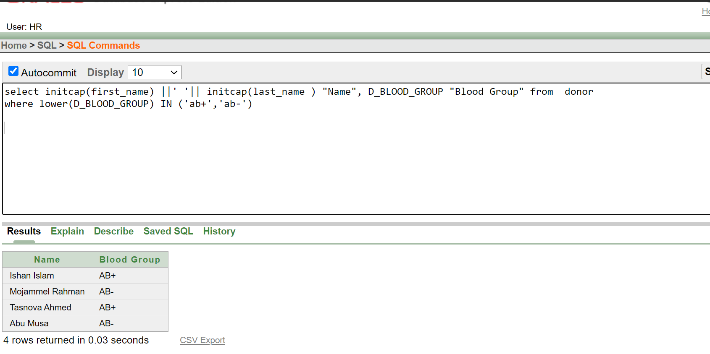

**Question 12 (Sequence ):** Inserting data using sequence in the id_info table

